1. Why are functions advantageous to have in your programs?

**Answer:** Function helps to divide the large programs into small groups so that we can read the code easier and debug the program faster and better.

Python Functions stop us from writing the same logic various times. We can bind the logic in one function and then call the same over and over.

**2**. When does the code in a function run: when it's specified or when it's called?

**Answer:** The code in a function executes when the function is called, not when the function is specified.

3. What statement creates a function?

**Answer:** With the def keyword (statement ) we can create a function .

4. What is the difference between a function and a function call?

**Answer:** A function is procedure to achieve a particular result while function call is using this function to achieve that task.

5. How many global scopes are there in a Python program? How many local scopes?

**Answer:** There is one global scope, and a local scope is created whenever a function is called.

6. What happens to variables in a local scope when the function call returns?

**Answer:** A local variable retains its value until the next time the function is called A local variable becomes undefined after the function call completes The local variable can be used outside the function any time after the function call completes.

7. What is the concept of a return value? Is it possible to have a return value in an expression?

**Answer:** A return value is the value that a function call evaluates to. Like any value, a return value can be used as part of an expression

8. If a function does not have a return statement, what is the return value of a call to that function?

**Answer:** If there is no return statement for a function, its return value is None.

9. How do you make a function variable refer to the global variable?

**Answer:** Variables that are created outside of a function (as in all of the examples above) are known as global variables.

Global variables can be used by everyone, both inside of functions and outside.

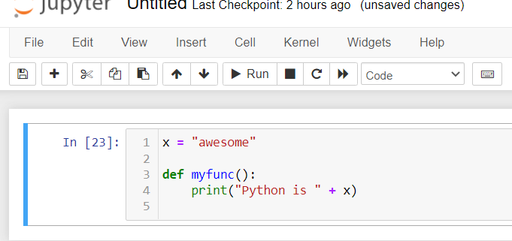

10. What is the data type of None?

**Answer:** The None keyword is used to define a null value, or no value at all. None is not the same as 0, False, or an empty string. None is a data type of its own (NoneType) and only None can be None.

11. What does the sentence import areallyourpetsnamederic do?

**Answer:** That import statement imports a module named areallyourpetsnamederic . (This isn't a real Python module, by the way.)

12. If you had a bacon() feature in a spam module, what would you call it after importing spam?

**Answer:** This function can be called with spam.bacon().

13. What can you do to save a programme from crashing if it encounters an error?

**Answer:** we don't want the program to unexpectedly crash on the user. Instead, error handling can be used to notify the user of why the error occurred and gracefully exit the process that caused the error

14. What is the purpose of the try clause? What is the purpose of the except clause?

**Answer:** The code that could potentially cause an error goes in the try clause.

The code that executes if an error happens goes in the except clause.